**AWS Customer Account Access**

1. Login to Idaptive.
2. Click the ***AWS Console (Customers)*** app. Note: you may also go directly to the AWS login page: <https://rrms-customer-access.signin.aws.amazon.com/console>

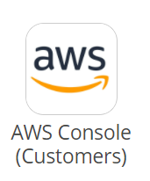

1. Enter your IAM username and temporary password. You will be required to reset the password the first time you login. Please note the password requirements below.

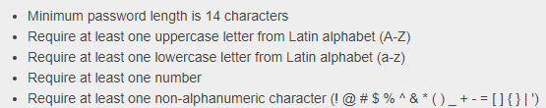

**Set up Multi-Factor Authentication**

1. Multi-factor authentication is required. To set this up, select the dropdown next to your username and click ***My Security Credentials***.

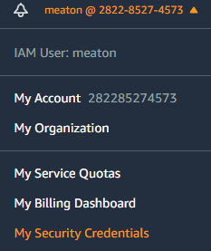

1. Click ***Manage MFA device***.

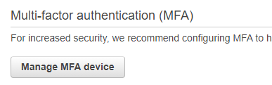

1. Choose ***Virtual MFA device*** and click ***Continue***.
2. Scan the QR code with your preferred MFA app and enter two consecutive MFA codes. When done, click ***Assign MFA***.
3. At this point, it is recommended to logout and log back in with the new credentials and MFA.

**Accessing Customer Accounts**

1. Once logged in, confirm the region is set to ***N.Virginia.*** Select the dropdown next to your username and click ***Switch Role***.

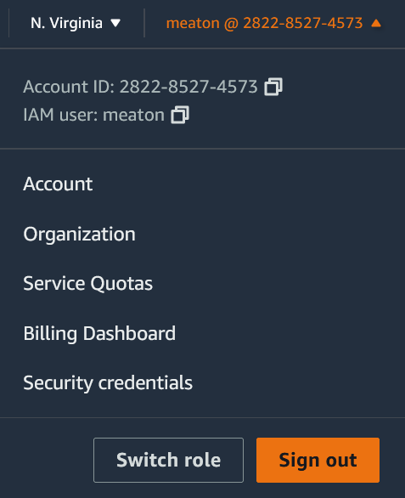

1. Enter the ***Account number*** and ***Role*** belonging to the customer. Refer to the table below. The *Display Name* can be whatever you like (the alias is shown below for convenience). Then click ***Switch Role*** and you will be logged into the customer account with the appropriate permissions.

|  |  |
| --- | --- |
| **Permission Level** | **Role Name** |
| Full admin access | RRMS-admin-access |

|  |  |  |
| --- | --- | --- |
| **Customer Name** | **Customer Alias** | **AWS Account Number** |
| American Council on Education | aceaws1 | 164521574824 |
| America's Health Insurance Plans | ahip | 980910698847 |
| American Petroleum Institute | api-aws | 732471999932 |
| Capitol Advisors | capitoladvisors | 632962955377 |
| Clark Enterprises | clarkenterprises | 079166085759 |
| Clark Realty Capital LLC | clarkrealty | 913433455355 |
| Close Up Foundation | closeupfoundation | 633874098170 |
| Cloudburst Consulting Group, Inc. | cloudburstconsultinggroup | 756542859819 |
| Continental Finance | CFC | 444151631972 |
| Du and Associates | duassociates | 253140374518 |
| ForeFront Power | forefrontpower | 374970414669 |
| Gerald Schwartz | geraldaschwartz | 309861474857 |
| Human Rights Campaign | hrc-aws | 756919752240 |
| HSC | hsc-aws | 811694592818 |
| HunterLab | hunterlab | 002438545100 |
| Kearney and Company | kearney | 424722411257 |
| Lerman Senter PLLC | lermansenter | 460728536768 |
| MAA | maa-aws | 779220606103 |
| NVAR | nvar | 172244193710 |
| Phi Beta Kappa | phibetakappa | 340769849823 |
| PWS | pws-aws | 278233815420 |
| State Services Organization | ssonet | 728566011901 |
| TIA | tia-aws | 508706316792 |
| Williams and Jensen | williamsjenson | 511981442765 |

1. To return to the **rrms-customer-access** account, click the account name and click **Switch back**.

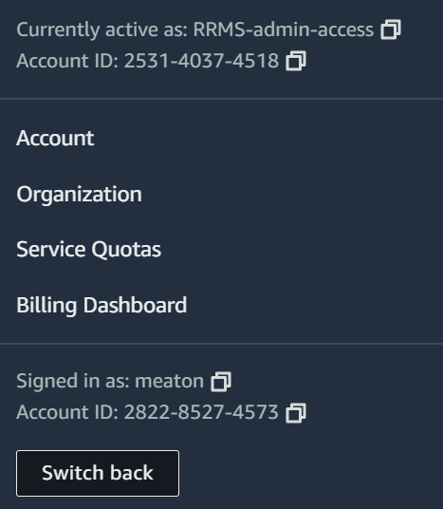

**Revision History**

|  |  |  |  |
| --- | --- | --- | --- |
| **Date** | **Version** | **Action** | **Resource** |
| 9/13/2021 | 1.0 | Initial Creation | Matthew Eaton |
| 12/17/2021 | 1.1 | Updated screenshots | Matthew Eaton |